Scientific journals that are published jointly with or in cooperation with the Scientific Association for Environmental Education and Sustainable Development.

1. Anthropogenic Pollution

The site of journal:

<https://oiccpress.com/ap>

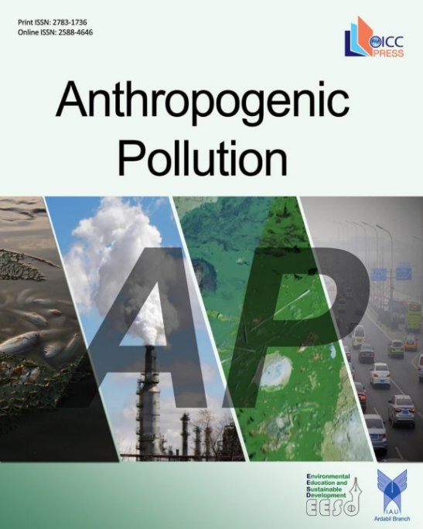

1. Environmental Geology

The site of journal:

<https://sanad.iau.ir/journal/geo>

